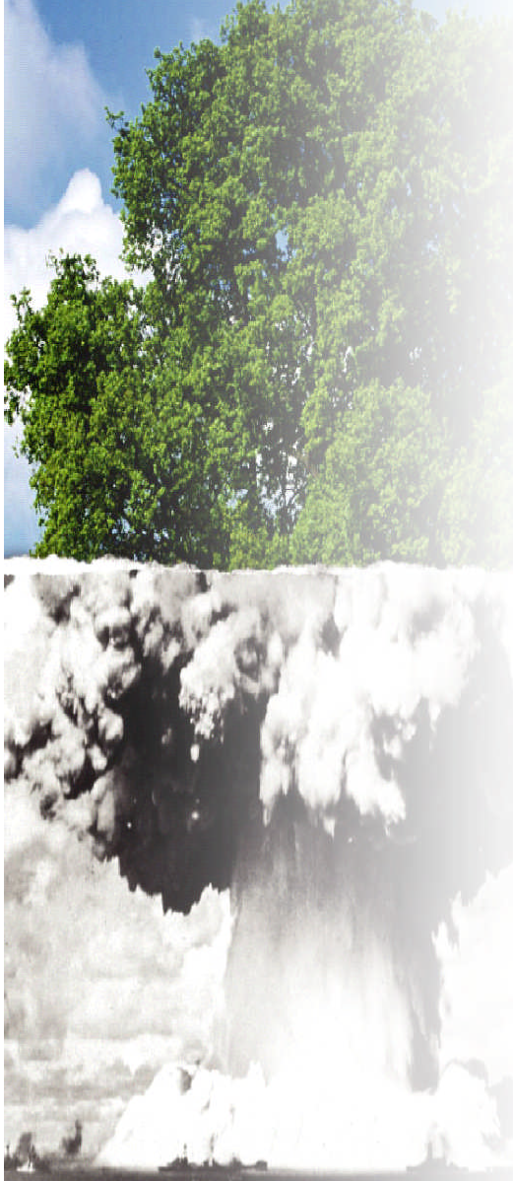
Freedom from
Nuclear Weapons
Most people want to live in a world free from the threat of nuclear weapons and many believe that any country which could even think of using them corrupts its own values. This hope has the backing of law. It is scarcely possible to imagine how nuclear weapons could ever be used lawfully and there is a solemn treaty obligation to negotiate in Good Faith for their global abolition.
However, no serious action has yet been taken by the few states which claim that their security depends on nuclear weapons. Thousands of these weapons of mass destruction are still ready to be launched at a moment's notice.
In July 2006 legal experts and civil society representatives met in Brussels to examine the legality of nuclear weapons in depth. The occasion was the tenth anniversary of the Advisory Opinion of International Court of Justice (ICJ), the World Court, on the Threat or Use of Nuclear Weapons. The conference developed proposals for action by citizens to uphold the law, calling on diplomats and politicians to honour their Good Faith obligations. Freedom from Nuclear Weapons records their conclusions and outlines a way forward.
The forces ranged against the view of illegality are truly colossal. However collisions with the colossal have not deterred the law on its upward course towards the concept of the rule of law. It has not flinched from the task of imposing constraints upon physical power when legal principle so demands. It has been by a determined stand against forces that seemed colossal or irresistible that the rule of law has been won.
Judge Christopher Weeramantry at the
International Court of Justice, July 1996.

Artwork: Jose Chicas/
Avenging Angels

I
Freedom from Nuclear Weapons
Conference Report
6 - 7 July 2006, Brussels, European Parliament
Edited by George Farebrother for World Court Project UK
Cheques for £7 (£5 each for orders of 5 or more) plus £1 per copy for postage in the UK, and £2 outside the UK, should be made payable to ‘Bertrand Russell House’ (if outside the UK, in Sterling, through a British clearing bank, otherwise please send cash).
Please complete the order form and send it with your payment to:
Spokesman Books, Russell House, Bulwell Lane,
Nottingham. NG6 0BT, England
E-mail elfeuro@compuserve.com
Fax 0044 1159 420 433.
For further details on The Spokesman and Spokesman Books, please visit our website on www.spokesmanbooks.com
US Distributor, Coronet Books inc. http://www.coronetbooks.com/
Please send me [ ] copies
[ ] I am paying by cheque made payable to 'Bertrand Russell House'
[ ] Please charge my (VISA, Mastercard, Switch, Solo and Electron)
Card Number

Expiry Date
Signature ………………………………….
Name (as on card) …………………………………………………………….
Address ……………………………………………………….………………...
……………………………………………………………………………………
Post Code ……………………… Country ………………………
Tel ……………………… Email …………………………………….……

